AEPHY2021
Narrogin SHS Year 11 ATAR PHYSICS Name:
Task No: | 9b
Task Type: | Science Inquiry
Content: | Linear motion and force
Unit context: | Vehicle movement and collisions
Task Description: | Answer the following questions  In class (test conditions) 20 minutes
Total Marks: | 16
Weighting: | 3%
Materials required | pens, pencils (including coloured), sharpener, correction fluid, eraser, ruler, highlighters, scientific calculator
Due Date:

- Complete the table below, including correct units. (10 marks)
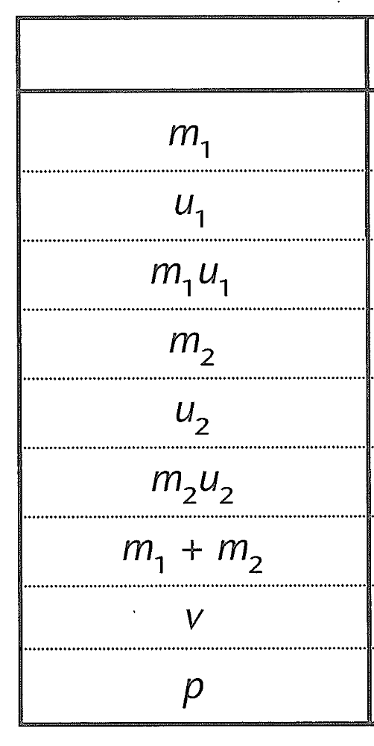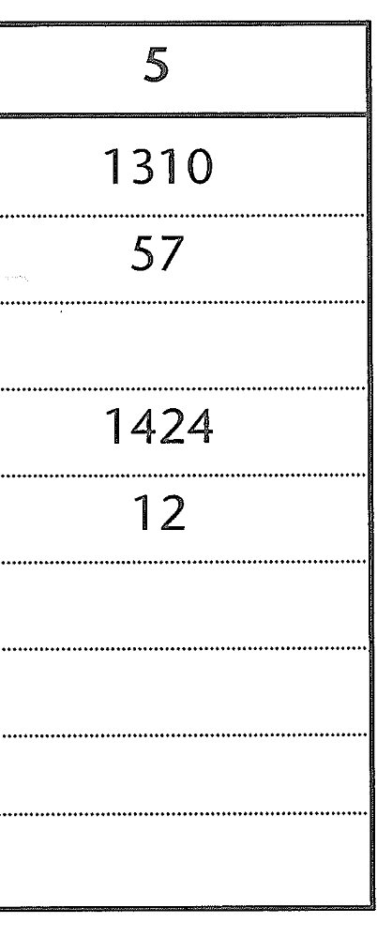
- Determine the acceleration for whiplash for the driver in the slower car (assume t=0.4s) (3 marks)

- Explain one factor that would need to be considered when designing a headrest (3 marks)

